A Detailed and Critical Analysis of the Kirkstall Valley Park White-Water Canoe Course Proposals

A report to Leeds City Council

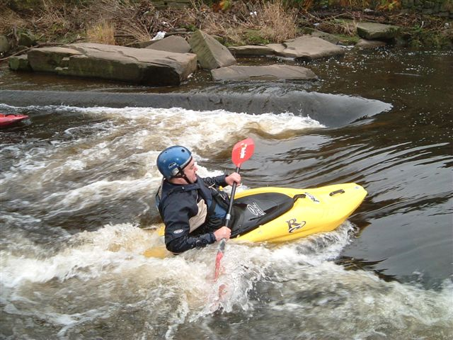

By Emma K. Waterhouse
MSc Catchment Dynamics and Management
University of Leeds
May 2004

University of Leeds
May 2004

CONTENTS PAGE NUMBER

- SUMMARY OF REPORT 2

- INTRODUCTON AND AIM 3
2.1. Kirkstall Valley Park Proposals
2.2. Leeds Canoe Club
2.3. Report Aims

- OPTION FOR THE CANOE COURSE 4-5

- FACTORS REQUIRING CONSIDERATION 6-15
4.1. Hydrology
4.1.1. Current river hydrology
4.1.2. The impacts the proposals may have on hydrology
4.2. Wildlife
4.2.1. Fish
4.2.2. Birds
4.2.3. Plant
4.2.4. Other wildlife
4.3 Archaeological features
4.4. Religious ceremonies
4.5. Locals and property owners
4.6. Other practical considerations

- RECOMMENDATIONS 16-18
5.1. Option 1 – mill goit 1
5.2. Option 2 – mill goit 2
5.3. Option3 – the main river channel
5.4. Option 4 – remove weir 1
5.5. Option 5 – develop current features
5.6. Option 6 – new channel
5.7. Recommendations

- FUTURE WORK 18-19

- REFERENCES AND ACKNOWLEGEMENTS 19-20

APPENDICES

1 Sketched map of study area
2 Leeds Canoe Club short term plans
3 Wildlife
4 Other UK canoe course
5 Sample interview

- SUMMARY OF REPORT

This report provides a critical overview of the proposals to construct a white-water canoe course on the River Aire as part of the proposed Kirkstall Valley Park (KVP) in Leeds. It initially outlines the KVP proposals and the needs and requirements of Leeds Canoe Club. There are extensive suggestions for the location and design of the canoe-course of which six contrasting options are noted. With these options in mind, the sections that follow give a detailed account of the factors requiring consideration before decisions on which scheme should be adopted are made. These considerations range from the hydrological and ecological impacts to the views of the local visitors and archaeologists. Each of the proposed schemes is then critically analysed and recommendations are made. The advised option is to greatly enhance the canoe features already built in the river channel providing Leeds Canoe Club with a challenging training facility that may be suitable for competitions. Further studies are required to fully understand the feasibility and the impacts of the proposals. These are suggested at the end of the report.

2. INTRODUCTION AND AIMS

2.1. Kirkstall Valley Park Proposals
The local plan in 1980 contained proposals for a Valley Park in Kirkstall although unfortunately these struggled to progress. However, recent developments have aimed to stabilise and advance the proposals further. Details of the plans can be found on the Kirkstall Valley Park Proposals website; www.images.leeds.ac.uk/kirkstallvalley.htm. The park aims amongst other things to enhance the local nature reserve, create an extensive network of footpaths and cycle-ways, to construct a children’s adventure playground and to develop a white–water canoe facility; the topic of this report. Appendix 1 contains a sketched map of the study area. This should be referenced throughout the report. Whilst much thought and research has gone into the park plans, the canoe proposals lack a summary report documenting the various options, factors that need considering and recommendations for the scheme. This report for Leeds City Council attempts to complete this essential task.

2.2. Leeds Canoe Club
The KVP proposals should greatly benefit Leeds Canoe Club who currently train on the river by the Morrisons complex. Despite the canoe facility in 1993 being “regarded as a centre of excellence and of national significance for its elite training, flat and moving water facilities” (NRA, 1993), the existing white-water features located downstream of weir 1 are limited.

The club has between 40 and 70 active members who train on the River Aire primarily in the summer. They are however unable to hold competitions due to the inadequate flow features and this is a great hindrance to the clubs development. The club have short-term plans to improve the river features which they are in the process of confirming with the Environment Agency. Appendix 2 contains a diagram of their plans. Through collaborations with the Council over the KVP, they would ideally like to improve the facilities further.

2.3. Report Aims
This report seeks to draw together a wide range of research to:
1) highlight the various potential options available for a canoe-course.
2) provide a detailed discussion of the factors requiring consideration before any developments are made.
3) critically examine each option and make recommendations on the most suitable scheme.
4) make suggestions about further research and study that may be required before further work can be carried out.

3. OPTIONS FOR THE CANOE-COURSE

The canoeists who already use the river at Kirkstall, paddle up to the Abbey and around the two river channels either side of the nature reserve island. For white-water canoeing, they concentrate particularly on the short reach downstream of weir 1 as shown in figure 1. They carry their canoes on foot over the reserve to return back upstream of the weir.

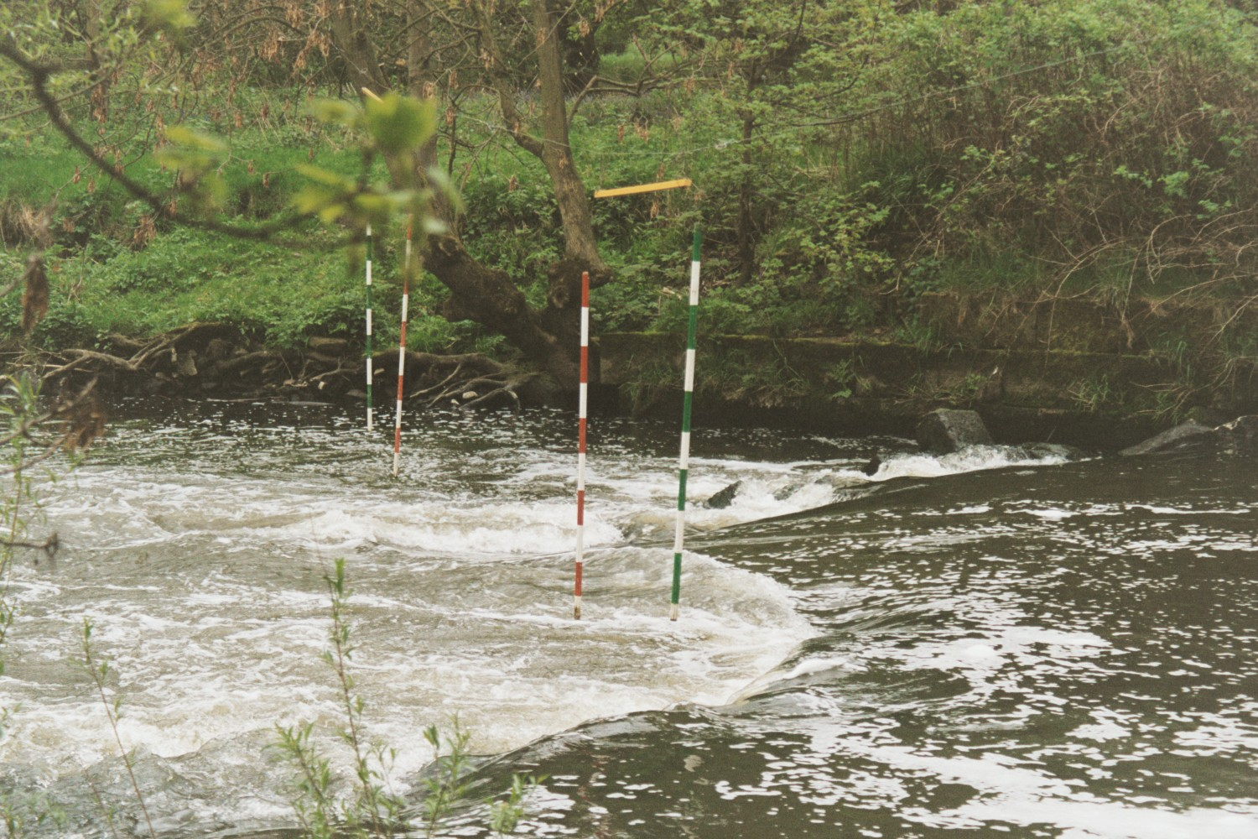
Figure 1: White-water canoe features downstream on weir 1.

It is essential that if money is to be spent, the proposals develop a useful and better facility than the current setup. A variety of ideas have been proposed by the British Canoe Union, Leeds Canoe Club and Councillor John Illingworth. The six most feasible and different options are shown in figure 2 and include:
- To use mill goit 1 to construct a new course.
- To use mill goit 2 to construct a new course.
- To develop features on the main river channel
- To remove weir 1 and develop features.
- To continue developing features downstream of weir 1.
- To cut a whole new channel through the nature reserve.
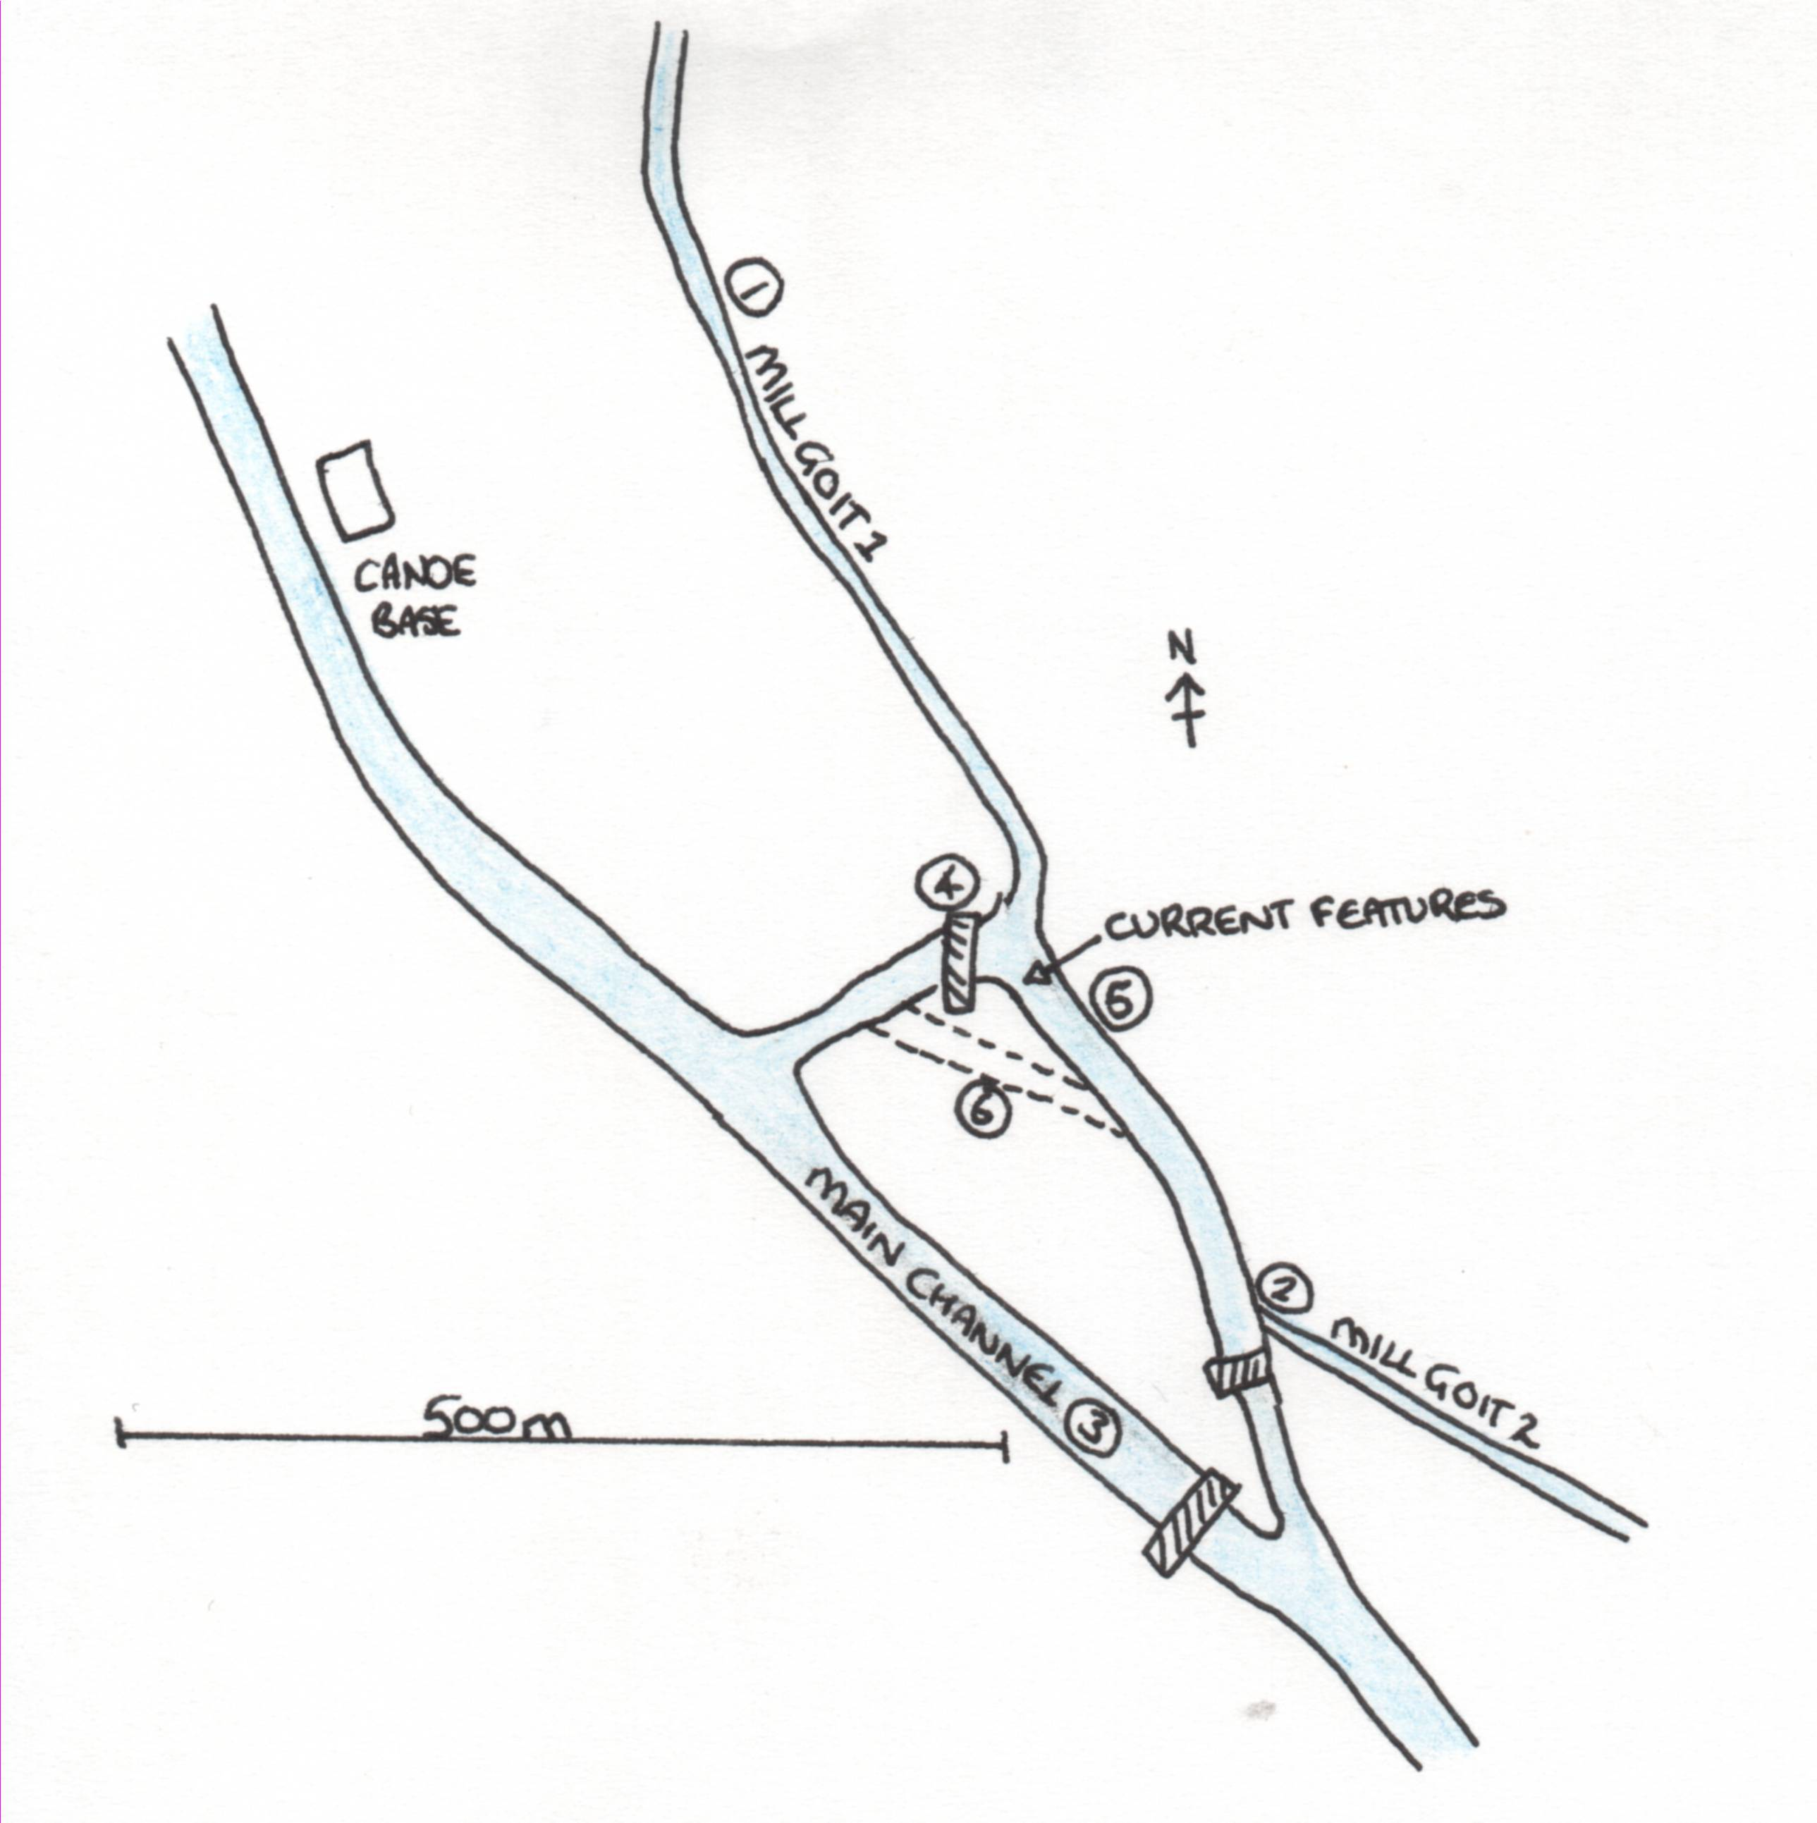
Figure 2: Diagram showing the various proposed schemes.

It can be seen that these options vary greatly in nature and thus have a variety of advantages and disadvantage that will be outlined later in the report. There are many other variations on these that are not discussed. It is hoped that this report will provide ideas, suggestions and considerations that can be applied to other ideas that may emerge as the proposals develop further.

- FACTORS REQUIRING CONSIDERATION

Ascertaining which scheme is the most appropriate will be a difficult task and as with any development will have opposition and pressure groups. The various different groups of people with views and concerns about the schemes are shown in figure 3 below. Alongside these opinions, consideration must be given to the feasibility of the proposals in terms of the hydrology, the hydrological impacts and the practical demands of the schemes. The sections that follow provide a detailed discussion of all the factors that need consideration.

Archaeologists

Sikhs and Hindus
Local Visitors
Property and land owners
Conservationists

CANOE COURSE

Leeds City Council
Environment Agency

Fishermen

Figure 3: Groups of people requiring consideration.

4.1. Hydrology
4.1.1. Current river hydrology
The hydrology of the river and mill system around Kirkstall is one of the most important factors requiring consideration. Under average summer flow, from Kirktsall Abbey around 10% of the river discharge enters mill goit 1 and the rest flows over the weir and down the main river channel. At the island, around 40% of the remaining flow is routed to the left of the island (over weirs 1 and 2) and the remaining 60% flows down the main river channel. The flow from mill goit 1 re-enters immediately downstream of weir 1. Mill goit 2 takes a very small percentage (around 5%) of the flow from upstream of weir 2. This re-enters the main river channel downstream by Burley Mills.

Careful consideration needs to be given to the flow nature, high and low flows and any potential long-term trends in the flow regime. The course needs to be designed for flows that provide the most usage. It may be impossible to canoe at low shallow flows and dangerous during flood conditions. Low flows in the two main river channels around the island are problems to an extent, particularly over the weirs but the Canoe Club currently train with limited problems. If changes in the discharge regime occur, problems may arise for the canoeists.

A river gauging station at Armley Mills (located just downstream of weir 3) provides valuable insight into the flow nature with daily flow records extending back to 1961. A detailed analysis of the data was carried out. Firstly, it can be seen from figure 4 that the river is flashy in nature with the highest flows typically occurring during the winter months.
Figure 4: River Aire daily discharge.

The high and low flows that occur on the river will pose the greatest problems for the canoeists. Figure 5 shows the number of days each year where the flow is either greater than 80m³s⁻¹ or lower than 3m³s⁻¹. This graph is interesting as it shows that the number of high flows is fairly constant at around an average of 5.5 days a year. Perhaps of more interest is the low flow plot which not only shows a period of around eight years (1970-1978) where low flows were very frequent but large annual variations. In recent years low flows have been less common.
Figure 5: Annual number of high and low flows.
Figure 6: Discharge Analysis Graphs
Annual trends appear to be present within the data as shown in figure 6. These graphs show the annual average, maximum and minimum daily discharges. All three graphs show lots of scatter but the general trends indicate that flows are annually increasing in magnitude.

The final crucial graph that needs to be examined is the flow duration curve for the data set. For complex purpose built courses, the designers use these curves to construct features for different flow conditions. Since the previous graphs have indicated long-term trends in the data, two flow durations curves were plotted (figure 7) for 1961-1962 and 2001-2002. These clearly show the long-term changes with the difference indicating that between 1961 and 2002, flows at all levels of exceedance (from the lowest to the highest flows) have increased. These findings correlate with the graphs in figure 6. The two data sets when tested for a significant difference using a two-sample equal variance t-test showed a significant t-value of 3.455. The significant difference raises some concern that future changes in the flow may occur and this needs exploring more carefully.
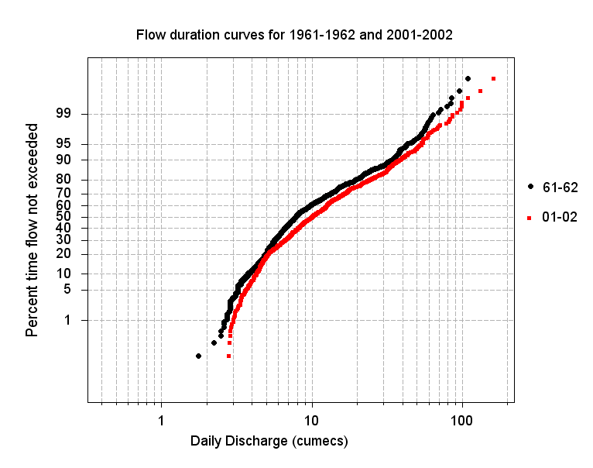
Figure 7: Flow duration curves for Armley Mills

4.1.2. The impacts the proposals may have on hydrology.
Any alteration to the flow or the morphology of the river channel is likely to have an impact on the conveyance and nature of the flow. Such changes may be negligible whilst others may have significant impact on erosion, flooding and aesthetics. To understand how a change in for example slope, bed roughness or channel width caused by the canoe-course can impact on the hydrology, we need to consider a few simple equations.
The principles of conservation of mass and momentum govern the principles of fluid flow (Lane, 1998) and are explained by Newton’s Laws of motion. The first equation (equation 1) deals with Newton’s First Law, the principle of mass of conservation. The volume of water that enters a river section, must equal that the leaves; if must go somewhere.
Q = vWD
Where: Q = discharge, v = velocity, W = channel width and D = channel depth
Equation 1

Hence, if we change the width or the depth of the channel or the velocity of the flow in order to create rapids or deeper flow, to maintain the discharge, the other parameters must also alter. Some scenarios that may occur through the canoe course construction are shown below:
- If the width of the channel is narrowed, the velocity should increase and white-water may be created. Yet it is also likely that erosion of the bed will occur deepening the channel. This eroded material is then deposited downstream where it is not wanted.
- If the channel is made shallower by placing boulders to create rapids, a possible response is for the channel to increase in width thus eroding the banks.
- If the channel velocity is slowed but placing boulders and rocks in the channel (this is called channel bed friction) to create features and the river cannot deepen or widen due to the mill wall features, the water entering the section cannot exit at the same rate. Since it must go somewhere, it will back upstream and potential spill out over upstream banks.

A second problem that may occur through construction of the canoe-course is a change in the slope of the channel. This would occur if a weir was removed. Equation 2 is for stream power; the rate at which potential energy is converted to mechanical energy available for sediment erosion. If all that changes in the river is the slope, the steam power also increases and there is extra energy available for the river to transport sediment. Erosion will occur particularly in the upstream direction as the river attempts to become graded again.
Ω = ρgQs
Where: Ω = stream power, ρ = density of water, g = gravitational acceleration,
Q = discharge and s =slope. Equation 2

Further considerations need to be given to any changes that may be made to the systems flow routing. For example re-routing more water down the mill goits may cause significant erosion and downstream deposition. This erosion may disturb polluted sediments that have remained untouched since the mills operated. A greater problem is perhaps the relocation of flooding. This may also be enhanced by changes that increase the flow conveyance of the channel.

Flooding is a large problem along the River Aire with the allotments (downstream of weir 2) flooding frequent (figure 8). This overspill onto the valley results in highly fertile soils. The EA’s indicative 1 in 100 year floodplain map shows the extent of large floods in the area (figure 9). These may shift if large alterations are made to the flow regime.
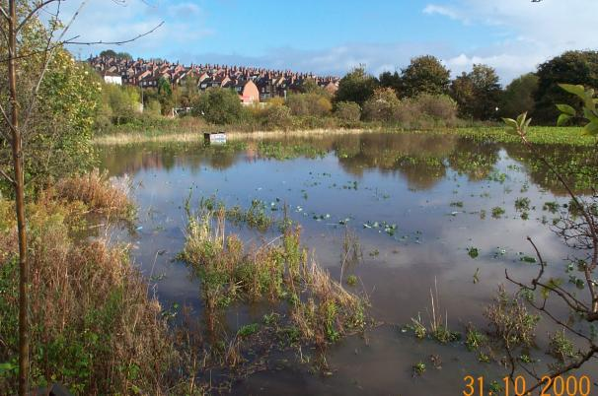

Figure 8: Flooding of the Burley allotments

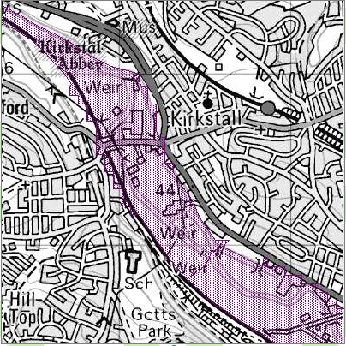

Figure 9: 1 in 100 year Flood Plain Map
(www.environment-agency.gov.uk) What’s in your backyard?

4.2. Wildlife
Disturbances to the natural habitats around the area must be given high priority since the “valley bottoms through Leeds are very important as ‘green corridors’” (NRA, 1993). Conservationists and locals have already raised fears about the proposals. Since 1992 the water and air quality along this stretch of river has been steadily improving and this alongside the opening of Kirkstall Valley Nature Reserve in 1992, has encourage wildlife back to the area. The nature reserve forms an extensive plateau built onto contaminated fly-ash lagoons from Kirkstall Power Station and a small island in the middle of the river. The section of reserve that is bounded by the canal is designated as a Site of Special Scientific Interest. The reserve is managed by the Yorkshire Wildlife Trust and forms an important link in the Aire Valley Wildlife Corridor. Wildlife is now abundant, varied and thriving and the following sections touch of some of the important wildlife characteristics. Appendix 3 provides lists of some of the wildlife present in the area.

4.2.1. Fish
In 1992, along this stretch of river, the chemical water quality was class 3, poor, whilst the biological quality was class B3, also poor (NRA, 1993). The improving water quality has allowed some of the best coarse fishing in the area in recent years. In addition this section of the river acts as a migration route for fish to the designated salmonid and cyprinid fisheries further upstream.

The proposed canoe-course may have two different effects on the fish populations. The first is enhancement through the creation of new habitats and spawning grounds around the creation of rapids. This may also aid the migration of fish upstream. On the other hand, the construction and use of the facilities may disturb the fish, and drive them away.

4.2.2. Birds
Birds are also in abundance in Kirkstall Valley and the nature reserve is a popular bird spotting area. The canoe-course may have detrimental effects on birds through disturbance of feeding and nesting grounds.

4.2.3. Plants
The plateau area of the nature reserve is predominantly grass and scrubland with pockets of planted herb rich meadows with wild flowers. The banks that slope to the river consist of wood and scrub providing the nesting habitats of many of the bird species. Whilst the canoe-course seems little threat to the plant-life, any changes in erosion, flooding or the proposal to cut a channel through the reserve will impact greatly on the present species.

4.2.4. Other wildlife
Otters are known to be resident in the area and the Yorkshire Otters and Rivers Project managed by the Yorkshire Wildlife Trust (YWT) based in Kirkstall aim to monitor and enhance the otter populations in the river. Unfortunately otters are highly sensitive to disturbance with the main factors driving them away including loss of habitat, inadequate food supply, disturbance of breeding sites and low flows. It is therefore likely that the development of the canoe course will have a negative impact on the otters. Further collaborations with the YWT need to be done to ascertain the level of damage.

Many other plant and animal species exist in the area. The important ones include numerous invertebrates on the grassy embankments on the reserve. Also roe deer are common all around the area but in particular on the island itself. These are extremely sensitive to human disturbance which could be an issue for the canoe proposals. Finally many species of waterfowl have been noted.

4.3. Archaeological Features
The Kirkstall area is steeped in history with numerous mills and weirs along the river, the popular tourist attraction Kirktsall Abbey and Gotts mansion and park most notable. The river was used to power many mills for the woollen industry during the 18th and 19th centuries with Armley Mills being constructed in 1806, Burley Mills in 1798 and St Ann’s Mills in 1824. Many of the mill buildings, features and weirs are still present and in good condition. However the proposals are based around many of these features including the mill goits and the weirs. Protecting and preserving the historic riverside archaeology is essential (NRA, 1993) with the weirs of particular concern as they are all listed features. The West Yorkshire Archaeological Society have been involved in the KVP proposals and feel that removing or unintentionally damaging the features would be a tremendous loss both historically and aesthetically.

Removing the weirs on the river would ideally provide an excellent canoe facility but the implications of weir removal are extensive as discussed in the EA’s 2003, “River Weirs – Good Practice Guide”. The environmental issues are both short and long term. Whilst short-term impacts include loss and disturbance of habitats, in the long-term the removal may be positive. Fish migration may be significantly enhanced for example. From an engineering point of view, the most important issue is the impact on the river stability. Severe erosion both upstream and on the channel banks may result in the undermining of walls and damage to other infrastructure such as bridges. Ecological and amenity impacts should also be considered.

4.4. Religious Ceremonies
There is a purpose built platform located by the start of mill goit 2 and weir 2 for Sikh and Hindu religious ceremonies. Traditionally in India, the River Ganges which is the most religiously significant river in India is used for ceremonies to scatter the ashes of the dead (CNN, 2002). Hindu’s believe that all rivers merge into one and flow up to god and therefore any river can be used for this ritual. A spokeswoman for the Hindu Cultural Society of Bradford explained that “because their bodies are cremated, it is very important for them to scatter the ashes in rivers”. There is very little information available on this platform suggesting that it is used infrequently. There is however some press coverage of proposals to allow this practice to occur in the River Aire at Apperly Bridge (CNN, 2002). It is probable that if the Sikh and Hindu populations living close to the scattering platform in Kirkstall still use the platform, they will be opposed to the canoe facility.

4.5. Locals and property owners
It is important to value the opinions of the locals who use the area and also the businesses that may be affected. Some of the comments made by local visitors are shown in figure 10. Appendix 5 contains a sample interview. Generally locals were enthusiastic and behind the proposals, however some were concerned about the noise and disturbance that the construction may cause to the wildlife. Local businesses may be more apprehensive about the impacts of the scheme such as erosion and altered flooding. Damages caused by the scheme need to be assessed.

Figure 10: Opinions of local visitors
4.6. Other practical considerations
Finally each of the schemes should be considered in terms of the following:
- Cost – the Canoe Club’s current proposals are virtually cost free but more extensive developments may require expensive materials and labour. Local funds may be available and there is also potential for lottery funding.
- Materials and construction issues – the river channel has limited rocks for building features. Other local sources of rock need to be investigated further. Further issues requiring investigation include the disturbance of contaminated land, the height of bridges and other river usage.
- Access – for construction purposes, access to the main road would be very useful. Also access to the water for the canoeists and spectators should be considered.
- The other proposals – all the KVP proposals need to work together.
- The overall success of the course - in order for the scheme to be a success, it must create the right sort of course for the purposes of the club. Therefore the amount of elevation drop, the potential length and the features that can be created must be considered. By looking at other courses in the UK (a summary of these courses is given in Appendix 4), it is difficult to see how such a scheme is feasible on the River Aire. Complex dam-release courses and purpose built channels are virtually impossible in Kirkstall and perhaps the course at Sowerby Bridge near Halifax (figure 11) is the style that the Kirkstall course should be based on.

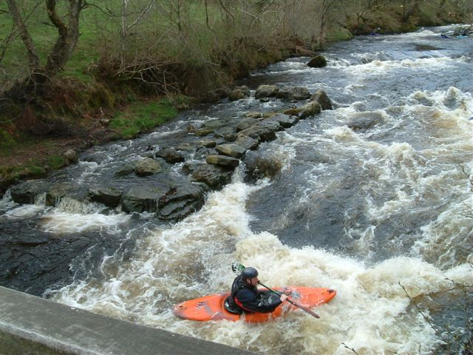
Figure 11: Course at Sowerby Bridge
Gavin Parry

- RECOMMENDATIONS

The previous section discussed the issues requiring consideration and these will be discussed further in this section of the report where each of the six proposed schemes will be critically examined. The advantages and disadvantages of each will be discussed.

  - Option 1- mill goit 1
The old mill goit would have originally held vast quantities of water and if the input by Kirktsall Abbey was opened up, it may provide a discharge suitable for the canoe-course. This scheme would make use of the full elevation drop from the Abbey to below weir 1, has good access with paths and roads all along the section and is a reasonable length. It also avoids the weirs and is located away from the nature reserve.

Yet this proposal has many potential problems. Firstly, in it’s current condition the mill goit has limited flow, it very shallow in places and not suitable for canoeing. Using the goit will have implications for the main river channel as flow would be reduced; the flow over the weirs may stop in the summer months reducing the aesthetics, lower flows may cause stagnant and polluted water and cause problems for the ecology. Furthermore, the channel is many places along the goit has no distinct banks and any increase in flow would cause flooding onto the surrounding land. New banks would be required. By re-routing some of the river flow, flooding may also be shifted down the goit and the establishments of Alders and Morrisions may be unhappy about the increased flood risk. Finally, many of the bridges along this section are currently low and may be impassable if the discharge increases (see figure 11). There are also mill features at both ends of the goit.

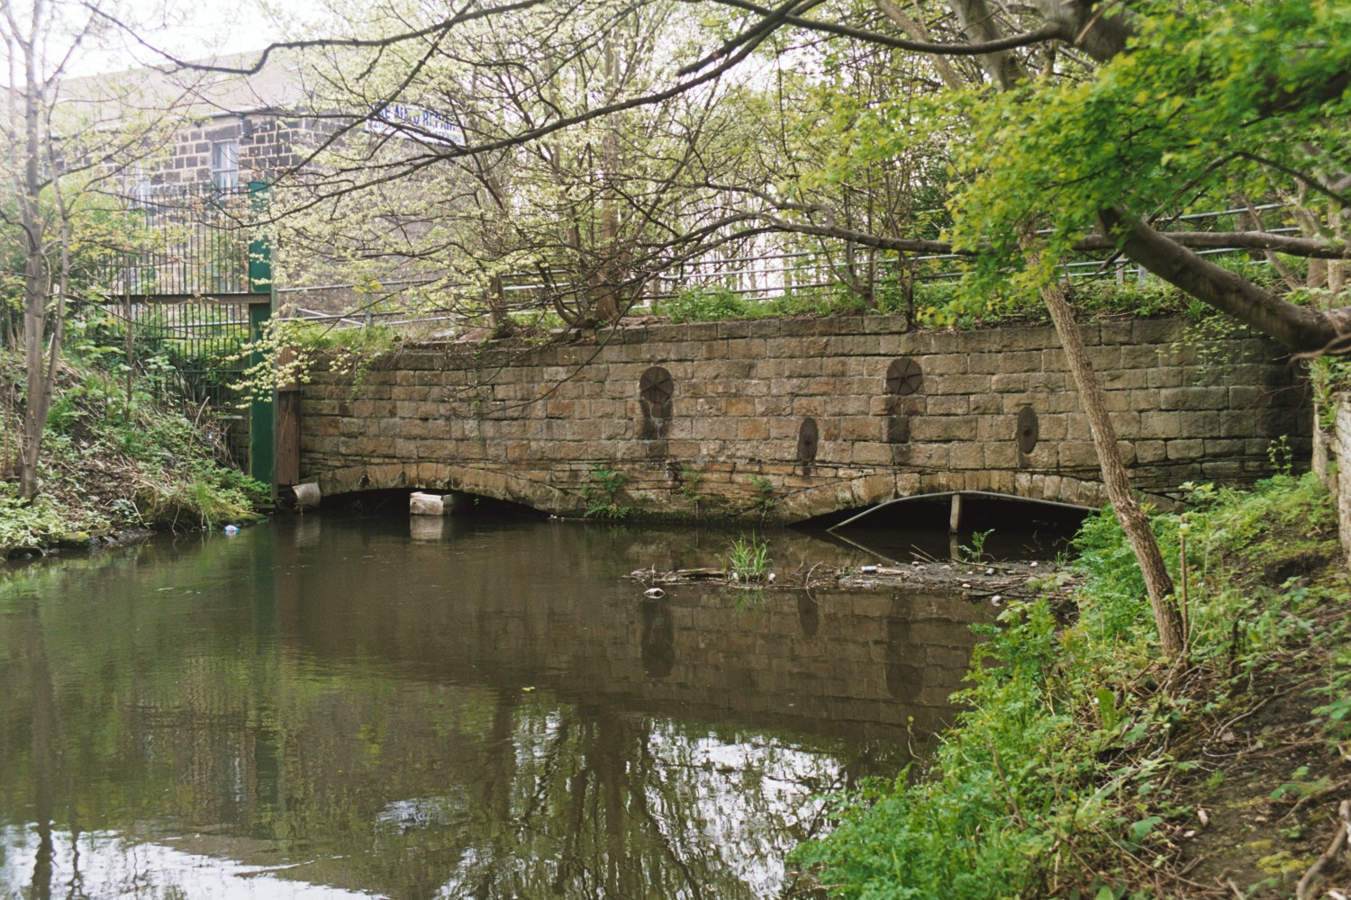

Figure 12: Photo of low bridge at St Ann’s mills.
5.2. Option 2 - mill goit 2
There are limited advantages to this option but these include reasonable access via the road and the current path, the course will be away from the nature reserve and will allow the weirs to be preserved.

However, this mill goit is in a far worse state of disrepair than mill goit 1 with only a small amount of flow and no definable banks. It would require significant extra flow and new banks. There is also the issue of the religious platform and mill features at the entrance to the goit and again flooding may be shifted away from the main channel. In addition the plans to build cycle paths and a children’s adventure playground along this section may not easily co-inside.

5.3. Option 3 –the main river channel
The main river channel is currently used by the canoeists for flat water paddling. A small feature is present in the form of the ford and the large weir further downstream (termed the boomer by canoeists) may provide a very challenging feature. However, the lack of elevation drop above this weir makes the scheme undesirable despite avoiding bridges and mill features. It also lacks access and the nature reserve on either side of the channel posses a problem. This scheme has little scope for a canoe-course.

5.4. Option 4 – remove weir 1.
Removing weir 1 will allow better utilisation of the drop in elevation and provide a longer more challenging canoe-course. This weir is in the greatest state of disrepair with several crest blocks already missing. Yet the removal of the weir is likely to cause significant upset. The archaeologists will attempt to preserve all the mill and weir features and removing the weir will be a great historic loss. It will be unknown what the impacts of the weir removal will be and channel instability may result in further loss of mill features around St Ann’s Mills. Significant disturbance to the wildlife will occur however the long-term impacts may be beneficial. Additionally, the changed flow regime could enhance upstream flooding or encourage more flow down the main river channel.

5.5. Option 5 – development of current features
This proposal is the least dramatic as is builds on the features already present. It would involve construction of more features similar to those currently proposed by the Leeds Canoe Club (appendix 2) downstream of weir 1. By carefully placing boulders and narrowing the channel, pools and eddies can be easily created. The Canoe Club will hopefully obtain permission to complete their own improvements in the near future. With help from the council through the KVP, local funds could provide more materials to be brought in and the facility greatly enhanced. This option would have minimal impacts on the flow regime although small changes may be experienced. The new rapids could enhance habitats and the disturbance through construction would be minimal. Since the drop is small, the scheme may not extend to weir 2. One major disadvantage is that the improvements may not be significant enough to allow competitions but certainly the training facilities would be improved.

5.6. Option 6 – New channel.
Cutting a new channel through the nature reserve to utilise the full elevation drop and avoid the weirs would certainly allow the construction of an extensive yet short course. It would have reasonable access and would be suitable for competitions and hence lottery funding.

Although, this proposal would more than likely have the greatest amount of opposition. Not only would it be extremely costly, it would severely damage the nature reserve and alter the flow regime both over weir 1 and downstream and probable enhance flow conveyance causing greater flooding downstream. Such a scheme would require significant further study but seems very unlikely in the short term.

5.7. Recommendation
An ideal course would have maximum elevation drop, be far away from the nature reserve, avoid the weir features and be cheap and easy to construct. This is almost impossible on the River Aire due to the many restrictions and hence compromises must be made. Option 5 seems to be the best proposal as this will create a good facility at minimal cost and with the minimal impacts. There may be further scope to use the mill goits as nursery courses for beginners.

- FURTURE WORK

Following these recommendations, the next stage in the development process is for the Council to decide on a scheme to be implemented. This decision should be based on the findings in this report alongside factors such as the available budget and the development of the other KVP proposals. Once a scheme has been chosen, detailed work should be carried out to determine the specific requirements for such plans, how they will be implemented and also the predicted impacts. Underlying all this work, careful thought must be given to the final outcome and whether it meets the requirements of the canoeists.

Such further studies should include determining where any materials will come from, how they can be placed in the river and the specific location of boulders for example. Also, detailed studies of the hydrology should be carried out particularly investigating any short–term changes in flow that may occur due to upstream changes in land-use, increased abstraction and potential climate change. Furthermore the potential impacts of the chosen scheme on the hydrology should be carefully documented. Some simple hydraulic modelling may be required to predict changes in flooding. Ecological studies would allow accurate estimates of the disturbance the chosen scheme will have on the wildlife to be made. By timing the construction, fish migration and bird nesting may be avoided and the disturbance minimised. If the chosen scheme runs near the scattering ground further investigation into its usage also need to be carried out. Finally, the scheme needs to be considered alongside the other KVP plans to determine how well integrated they are and the plans must be approved by the Environment Agency.

In conclusion, the development of a better canoe facility on the River Aire is a difficult and complicated task but should be feasible provided the changes made are not too radical and carefully thought though.

- ACKNOWLEGEMENTS AND FURTHER READING

Acknowledgements

Kirkstall Nature Reserve, West Yorkshire Wildlife Trust, Warden Joanna Mawson

Leeds City Council – Councillor John Illingworth

Leeds Canoe Club – Gavin Parry and Justin Scott

Second Site Properties – John Collins, Regional Estates Manager

West Yorkshire Archaeology Society - Helen Gomersall

West Yorkshire Otters and River Project, Hollybush Farm, Kirkstall

References and Further Reading

Armley Mills, www.leeds.gov.uk/armleymills/ (accessed; 04/04)

British Canoe Union, www.bcu.org.uk (last accessed; 05/04)

CNN, (2002), “Hindus apply for ‘Ganges’ in UK”, www.cnn.com.world (accessed; 13/05/04).

Environment Agency, “What’s in your backyard?” www.enviornemtn-agency.gov.uk (accessed; 05/04)

Holme Pierepont Canoe Course, www.hppslalomcourse.co.uk (accessed 04/04)

Kirkstall Valley Park Proposals, www.images.leeds.ac.uk/kirkstall valley.htm (last accessed; 12/05/04)

Kirkstall Online Forums, Discussion Board, Kirktsall Valley Park, www.kirkstall.org.uk/board/forum_posts, (accessed; 29/03/04)

Lane, S.N., (1998), “Hydraulic modelling in hydrology and geomorphology: A review of high resolution approaches”, Hydrological Processes, 12: 1131-1150.

McKenzie, M.L., (2004), “Site Visit Report: Kirkstall Valley Report: White-Water Course, River Aire Leeds”, British Canoe Union, Planning Facilities Department, Draft Report, 16/03/04.

National Rivers Achieve, Armley Mills (1961-2003 data), Station: 27028, www.nwl.ac.uk

National Rivers Authority, (1993), “River Aire Catchment Management Plan”, NRA, Northumbria Yorkshire Region.

Nene Canoe Course, www.nenewhitewatercentre.co.uk (accessed 04/04)

Old maps, www.old-maps.co.uk

Rickard, C., Day, K. and Purseglove, J., (2003) “River weirs – Good practice Guide”, Environment Agency.

Rowe, R., (1989), “Canoeing Handbook”, 2nd Edition, British Canoe Union, Biddles Limited, Surrey.

Teeside Canoe Course, www.4seasons.co.uk (accessed; 04/04)

Waterscape, “River Aire Waterways Guide”, www.waterscape.com/waterwaysguide/waterways/River_Aire. (accessed; 29/03/04)

